**What is Laravel ?**

Laravel is a framework of php

Laravel is used MVC architectures

Laravel is create a dynamic web applications or website.

Laravel provides its own structures i.e follow MVC.

Laravel used OOPS

Laravel official website is

<https://laravel.com/docs/9.x>

Laravel 10.x is lates version and lower version is Laravel 4.2

Laravel 9.0 is used to support php 8 or 8.1.0 >version.

Laravel is used to create a large scale of website or web apps

Laravel is easy to learn and provides more securities in your apps.

Laravel is default support seo friendly website.

Laravel provides some features while create application

Laravel features :

a) provides MVC architectures

b) support OOPS

c) provides seo friendly website

d) support unit testing

e) support php artisan

f) support database migrations

g) support blade templating

h) support eloquent ORM model

i) provides secured applications

how to create project in Laravel

a) download composer and install it

<https://getcomposer.org/download/>

b) how to check composer is install or not ?

D:\xampp\htdocs>composer

______

/ ____/___ ____ ___ ____ ____ ________ _____

/ / / __ \/ __ `__ \/ __ \/ __ \/ ___/ _ \/ ___/

/ /___/ /_/ / / / / / / /_/ / /_/ (__ ) __/ /

\____/\____/_/ /_/ /_/ .___/\____/____/\___/_/

/_/

Composer version 2.5.8 2023-06-09 17:13:21

Note : composer is an dependency manager i.e used to create an projects of Laravel and its also used to install packages in Laravel.

c) how to create an project of Laravel using composer

D:\xampp\htdocs>composer create-project laravel/laravel laravel-shoping-app "9.0.*"

D:\xampp\htdocs\laravel-shoping-app>

d) how to run Laravel project

D:\xampp\htdocs\laravel-shoping-app>php artisan serve

INFO Server running on [http://127.0.0.1:8000].

Press Ctrl+C to stop the server

<http://127.0.0.1:8000/>

e) how to create Laravel app on maintenance mode

D:\xampp\htdocs\laravel-shoping-app>php artisan down

INFO Application is now in maintenance mode.

f) after maintannace if application on live mode

D:\xampp\htdocs\laravel-shoping-app>php artisan up

INFO Application is now live.

Laravel server development URL

<http://127.0.0.1:8000/>

Laravel run on Localhost

<http://localhost/laravel-shoping-app/>

chanages in public/index.php and after paste index in Laravel main directory

$app = require_once __DIR__.'./bootstrap/app.php';

require __DIR__.'./vendor/autoload.php';

**Laravel directory :**

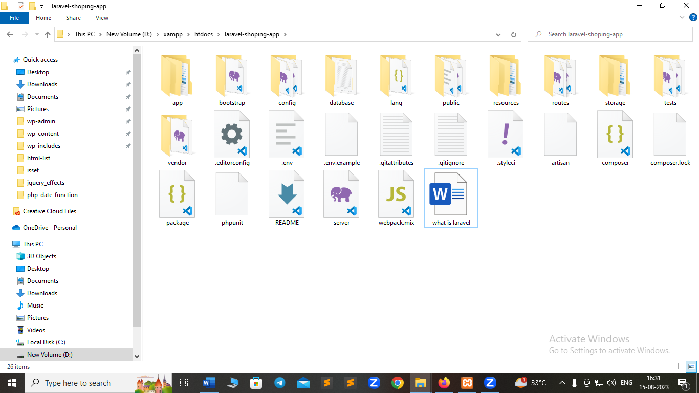

How to create a database and provides connections in app:

a) create a database inside of

<http://localhost/phpmyadmin/>

shopping-laravel-db

b) create a database connection open .env file

DB_CONNECTION=mysql

DB_HOST=127.0.0.1

DB_PORT=3306

DB_DATABASE=shopping-laravel-db

DB_USERNAME=root

DB_PASSWORD=

c) after create a database create a migration in Laravel

what is migration in Laravel ?

migration is create a schema of database tables or create a tables structures in Laravel there we used migrations.

database\migrations

a) php artisan make:migration create_countries_table

b) php artisan make:migration create_states_table

c) php artisan make:migration create_cities_table

after create migrations or schema of tables done migrate of table structure in database :

php artisan migrate

    public function up()

    {

        Schema::create('componies', function (Blueprint $table) {

            $table->increments("id");

            $table->string("compname");

            $table->timestamps();

        });

    }

 public function up()

    {

        Schema::create('department', function (Blueprint $table) {

            $table->increments("id");

            $table->integer("companyid")->unsigned();

            $table->foreign("companyid")->references("id")->on("componies");

            $table->string("departmentname");

            $table->timestamps();

        });

    }

 public function up()

    {

        Schema::create('employees', function (Blueprint $table) {

            $table->increments("id");

            $table->integer("depid")->unsigned();

            $table->foreign("depid")->references("id")->on("department");

            $table->integer("companyid")->unsigned();

            $table->foreign("companyid")->references("id")->on("componies");

            $table->string("empname");

            $table->string("photo");

            $table->string("name");

            $table->string("password");

            $table->bigInteger("phone");

            $table->string("gender");

            $table->string("hobby");

            $table->text("address");

            $table->timestamps();

        });

    }

**addtocart migrations :**

categories

id catname

subcategries

id catid subcatname

products

id catid subcatid photo pname qty price offerprice descriptions

carts

id userid pid offerprice qty subtotal status

order

id userid cartid qty subtotal status

bill

id userid cartid qty subtotal status

**make migration command**

php artisan migrate

migrate:fresh Drop all tables and re-run all migrations

migrate:install Create the migration repository

migrate:refresh Reset and re-run all migrations

migrate:reset Rollback all database migrations

migrate:rollback Rollback the last database migration

migrate:status Show the status of each migration